Roll No: 241901108
Name: T.Siva Sankari
Experiment: 9

DESIGN A SIMPLE TOPOLOGY AND CONFIGURE WITH ONE
ROUTER, 2 SWITCHES AND PCS USING CISCO PACKET TRACER

AIM:
To design and configure a simple network topology with one router, two switches, and multiple PCs using Cisco Packet Tracer for basic communication.

ALGORITHM:
1. Start Cisco Packet Tracer.
2. Drag and place 1 Router, 2 Switches, and 4 PCs.
3. Connect the devices using straight-through cables.
4. Assign IP addresses to all PCs and router interfaces.
5. Configure the router interfaces with the given IP addresses and enable them.
6. Save the configuration.
7. Ping between PCs to check network connectivity.

CODE:
Router>enable
Router#configure terminal
Enter configuration commands, one per line. End with CNTL/Z.
Router(config)#interface gigabitEthernet0/0
Router(config-if)#ip address 192.168.1.1 255.255.255.0
Router(config-if)#no shutdown

Router(config-if)#
%LINK-5-CHANGED: Interface GigabitEthernet0/0, changed state to up
%LINEPROTO-5-UPDOWN: Line protocol on Interface GigabitEthernet0/0, changed state to up
exit

Router(config)#interface gigabitEthernet0/1
Router(config-if)#ip address 192.168.2.1 255.255.255.0
Router(config-if)#no shutdown

Router(config-if)#
%LINK-5-CHANGED: Interface GigabitEthernet0/1, changed state to up
%LINEPROTO-5-UPDOWN: Line protocol on Interface GigabitEthernet0/1, changed state to up
exit

Router(config)#exit
Router#
%SYS-5-CONFIG_I: Configured from console by console
write memory
Building configuration...
[OK]
Router#

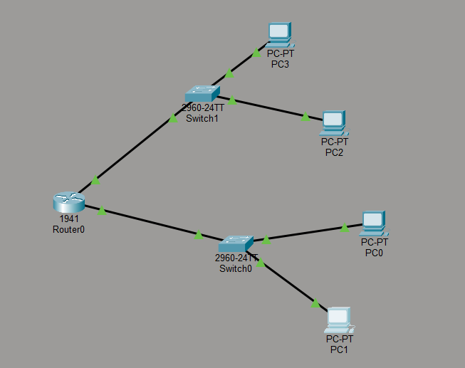

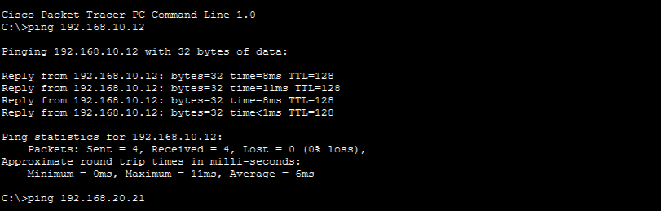
RESULT:
Thus, the simple topology using router, switches and PCs are made using
Cisco Packet Tracer.

